**WEEK - 3**

**SKILL : SPRING DATA JPA WITH SPRING BOOT, HIBERNATE**

**Mandatory Hands-on exercises Exercise: Spring Data JPA - Quick Example Project Structure:**

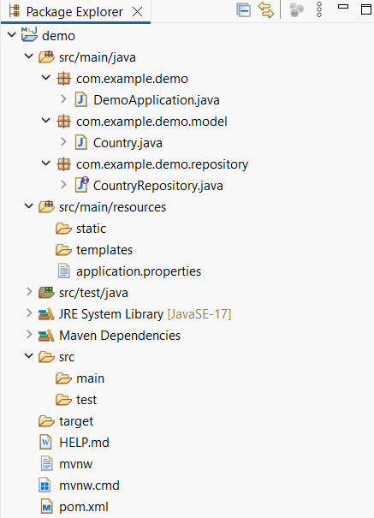

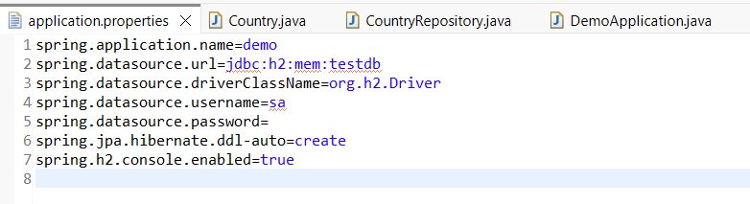**applicationproperties:**

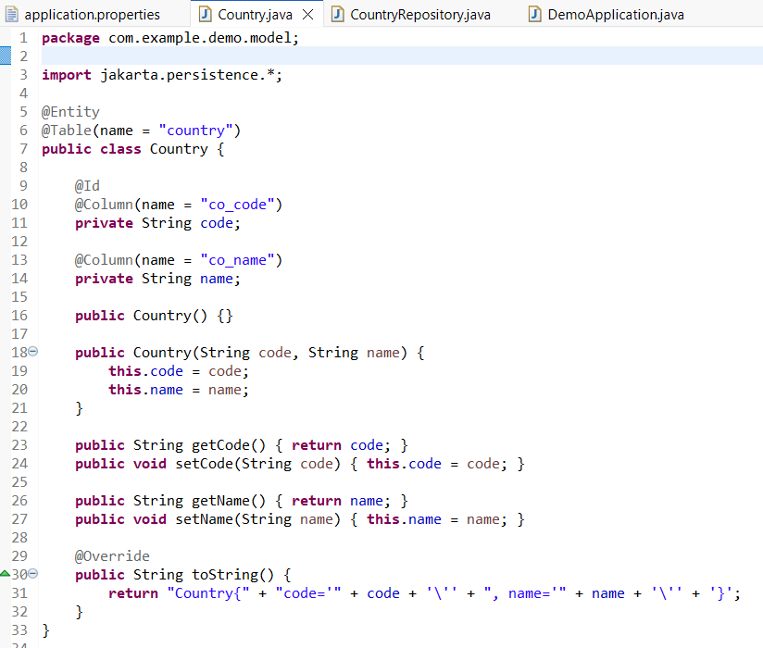

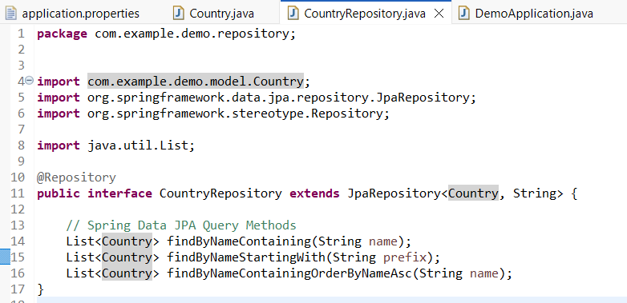**CountryRepository.java:**

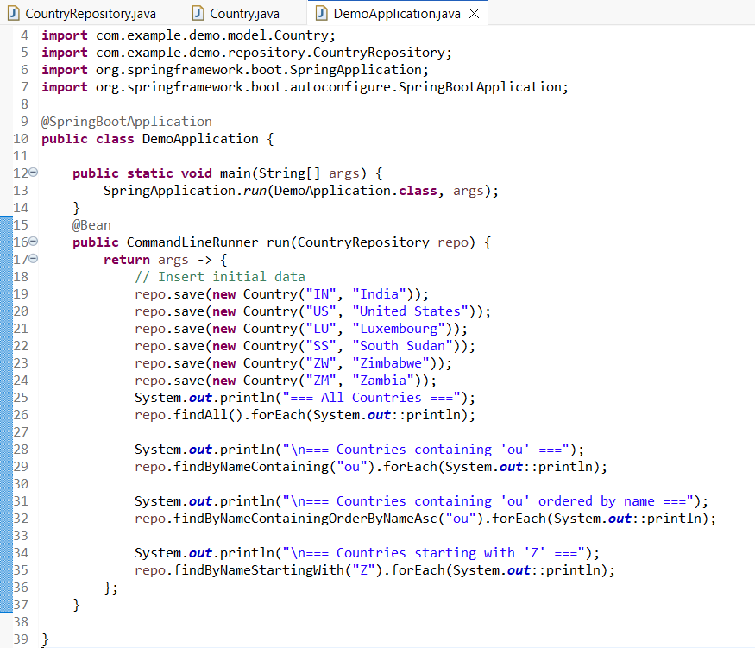

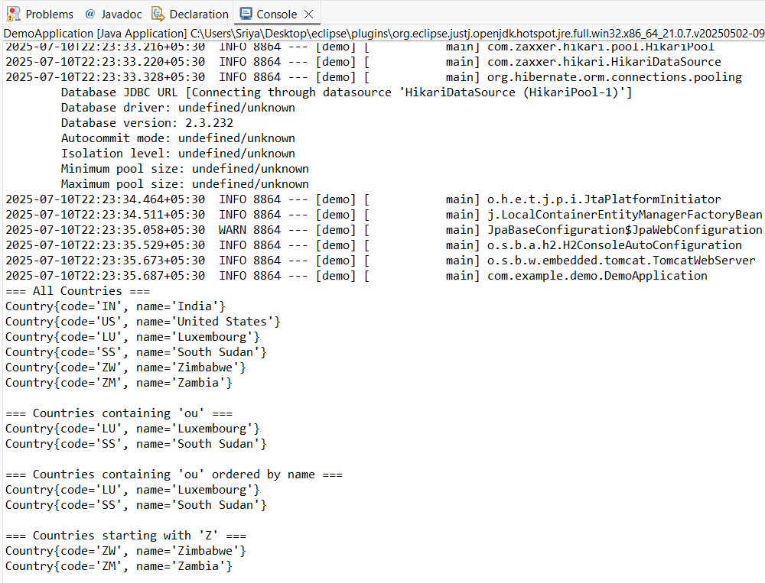

# JPA (Java Persistence API):

* JPA is a specification defined by Oracle for managing relational data in Java applications using object-relational mapping (ORM).
* It provides a set of interfaces and annotations for defining how Java objects map to database tables and how persistence operations (like saving, retrieving, updating, and deleting data) are performed.
* JPA itself does not provide an implementation; it defines a standard API that ORM frameworks can implement.

# Hibernate:

* Hibernate is a popular implementation of the JPA specification.
* It is a full-featured ORM framework that provides the concrete classes and logic to perform object-relational mapping and interact with databases according to the JPA standard.
* Hibernate offers additional features beyond the JPA specification, such as advanced caching mechanisms and custom query capabilities (HQL).

# Spring Data JPA:

* Spring Data JPA is a higher-level abstraction built on top of JPA and its providers (like Hibernate) within the Spring Framework.
* It aims to significantly reduce the boilerplate code required for data access layers by providing a set of conventions and interfaces for defining data repositories.
* Spring Data JPA can automatically generate common database queries based on method names in repository interfaces (e.g., findByLastName(String lastName)).
* It simplifies transaction management and integrates seamlessly with other Spring components.

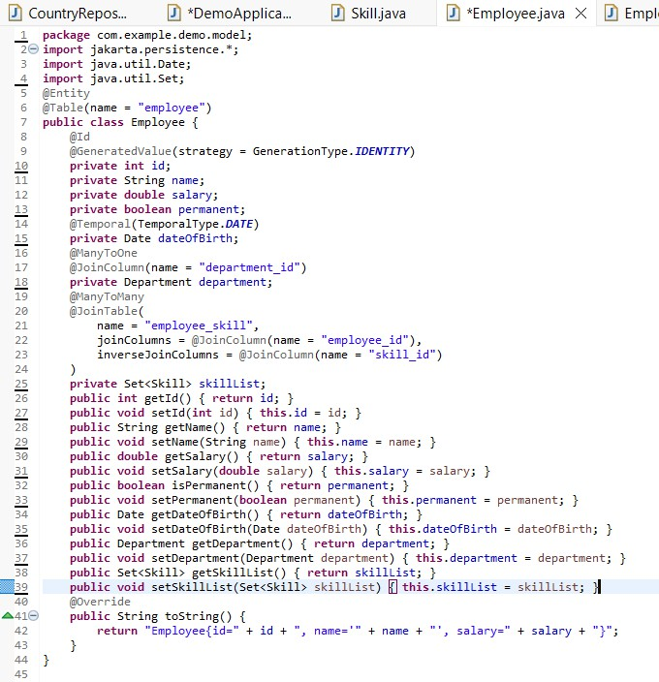**Employee.java:**

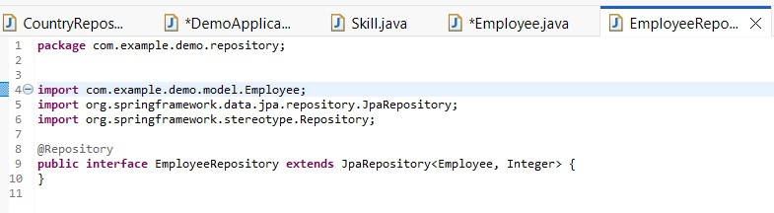**EmployeeRepository.java:**

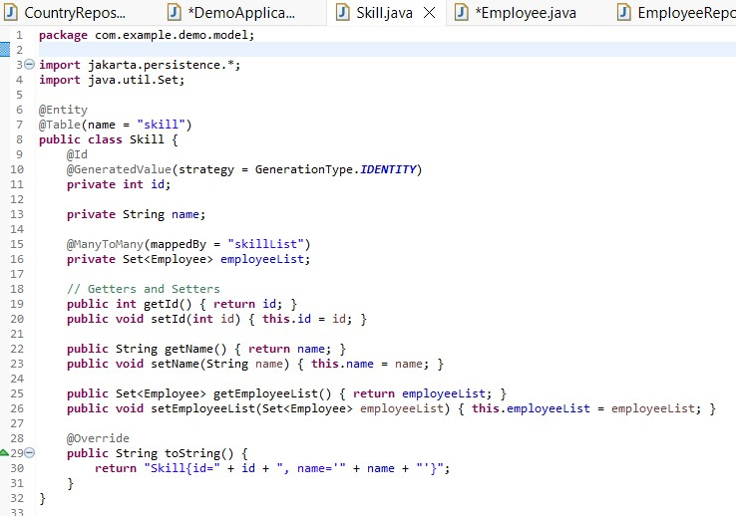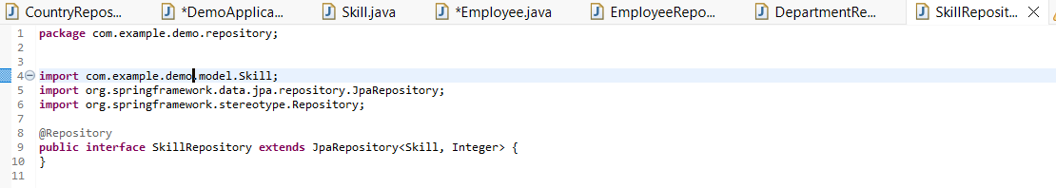**SkillRepository.java:**

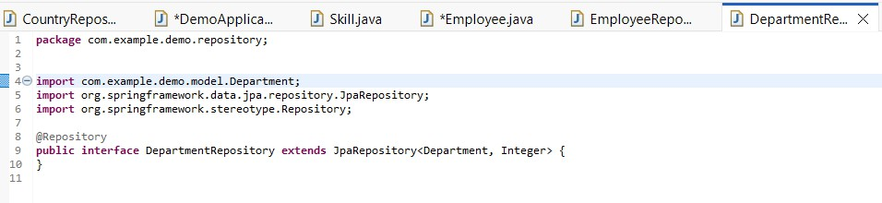**DepartmentRepository.java:**

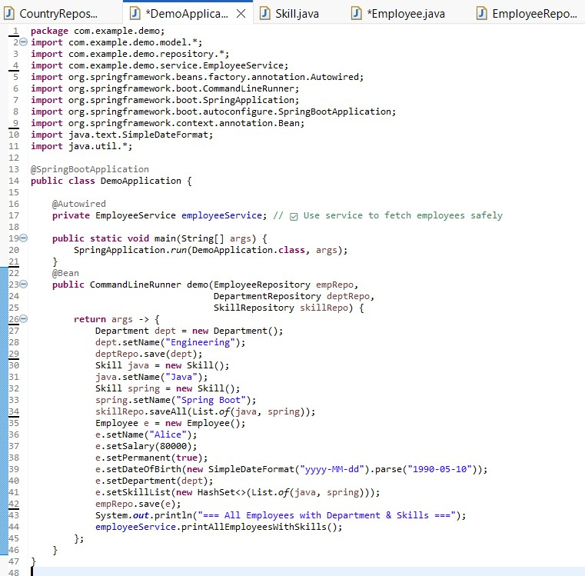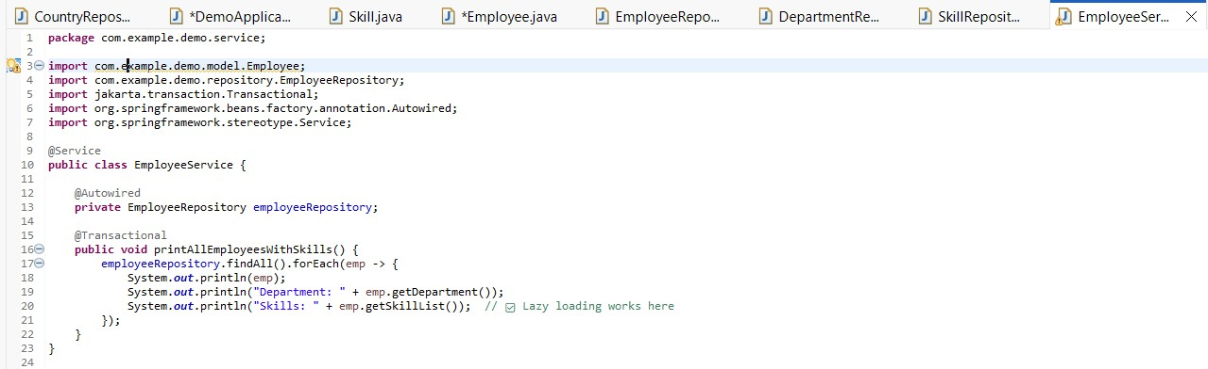**EmployeeServices.java:**

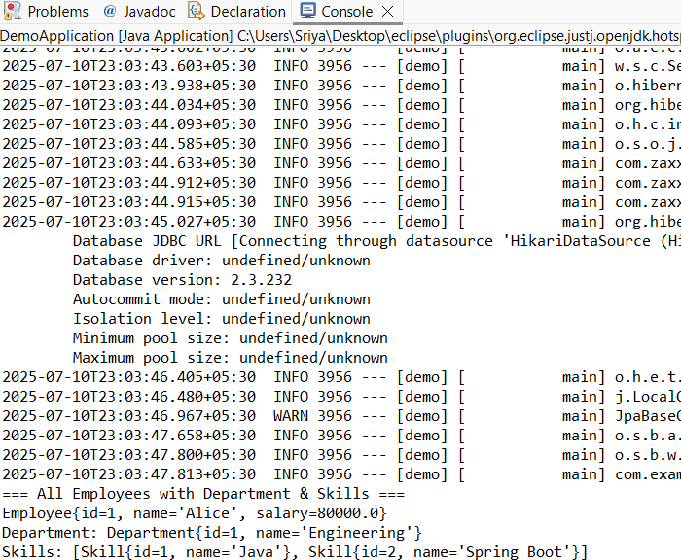

**Project Structure:**



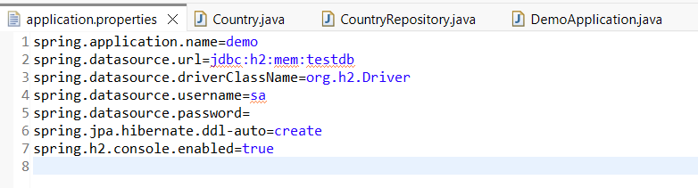**Application properties:**



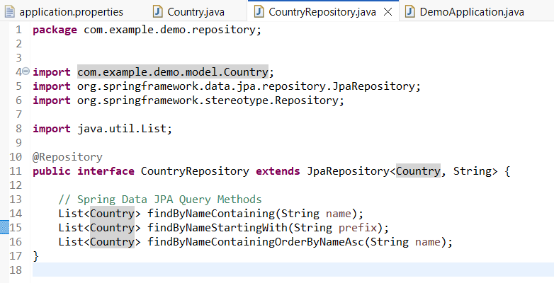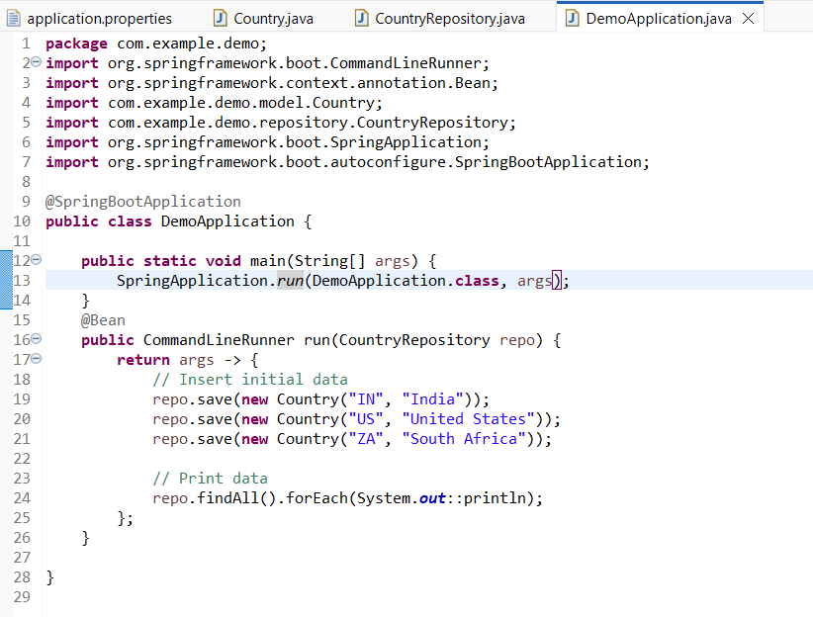**DemoApplication.java:**

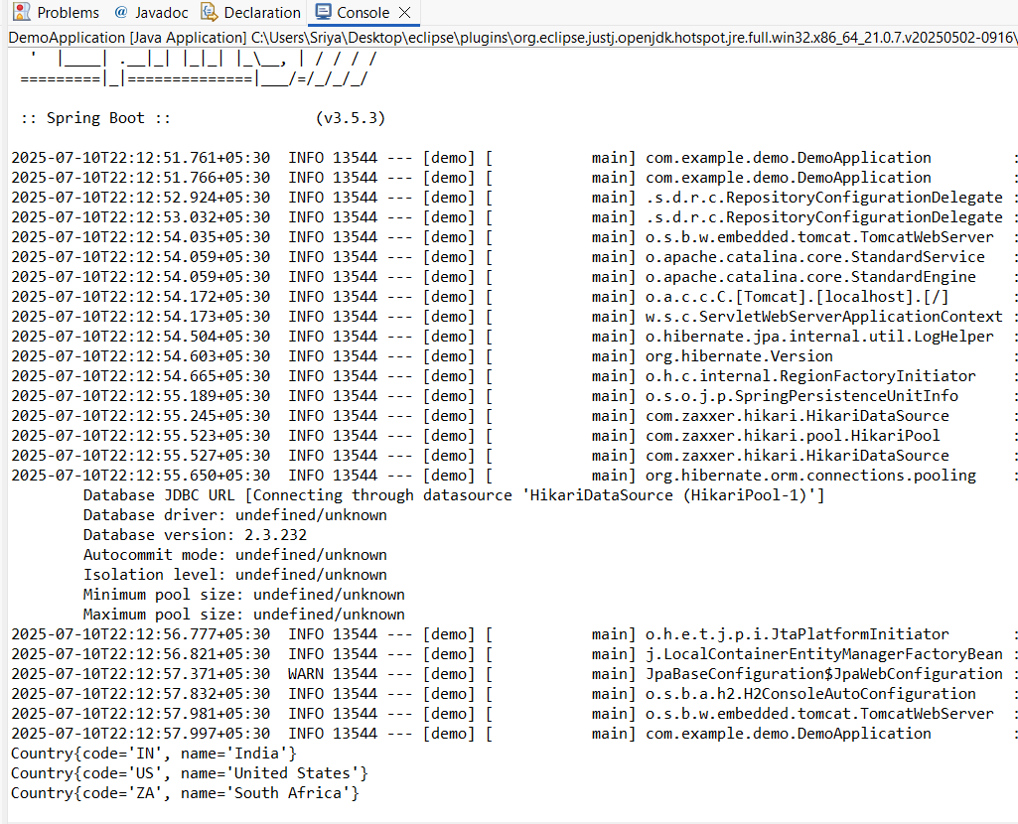

**Country.java:**

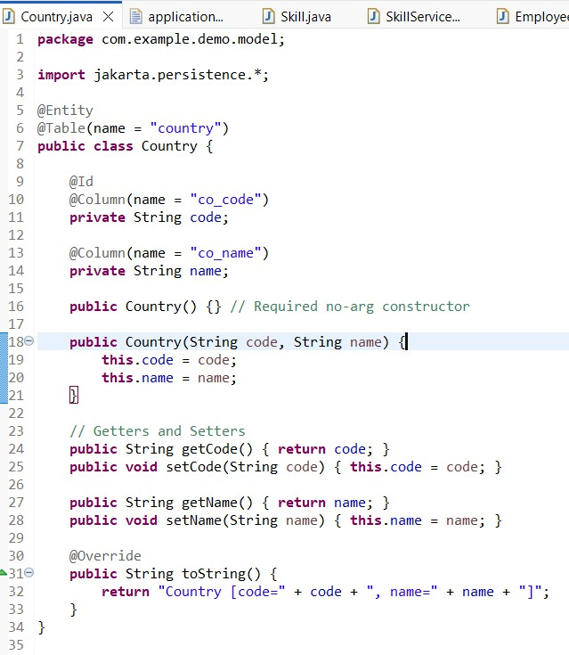

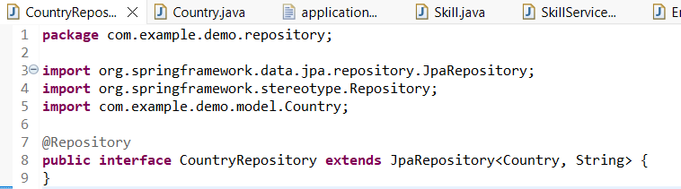**CountryRepository.java:**

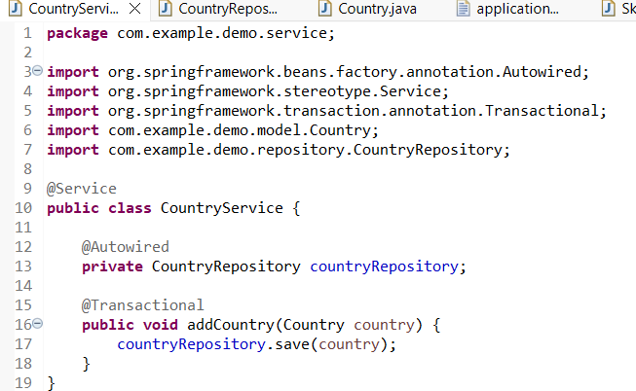

**DemoApplication.java:**

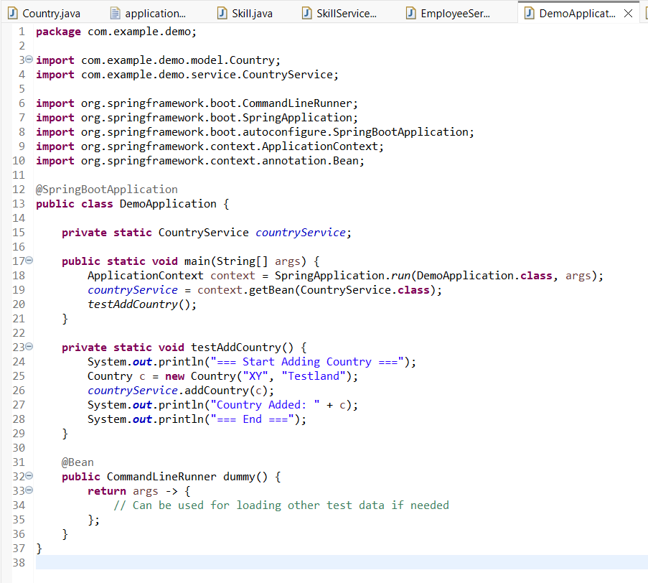

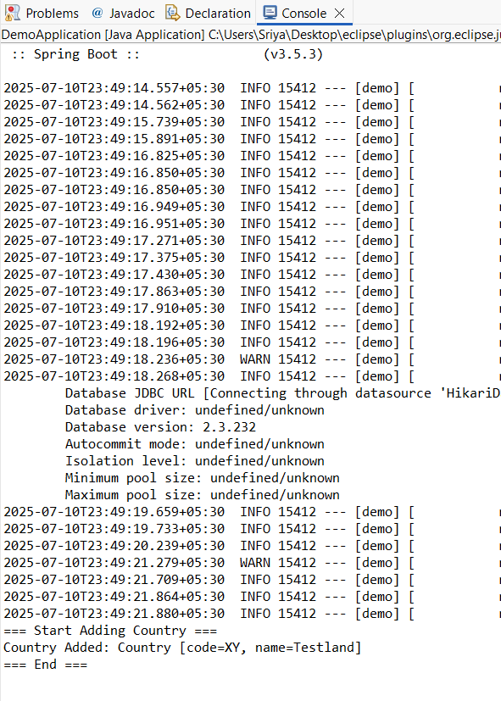

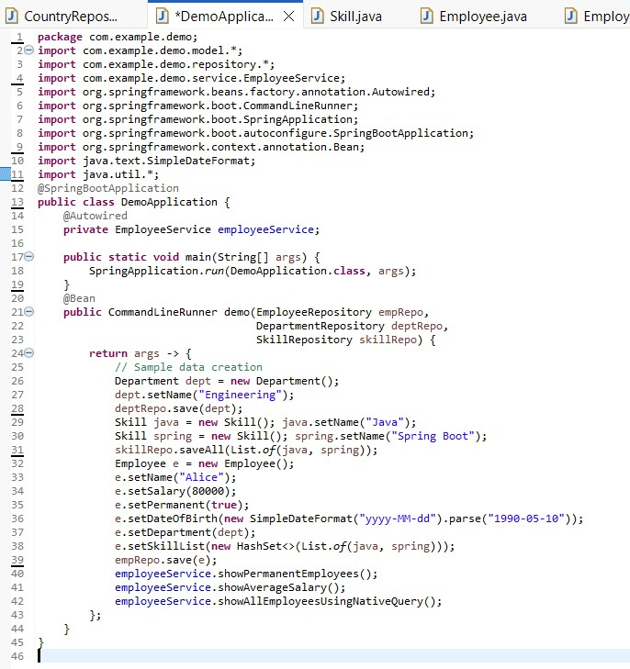**DemoApplication.java:**

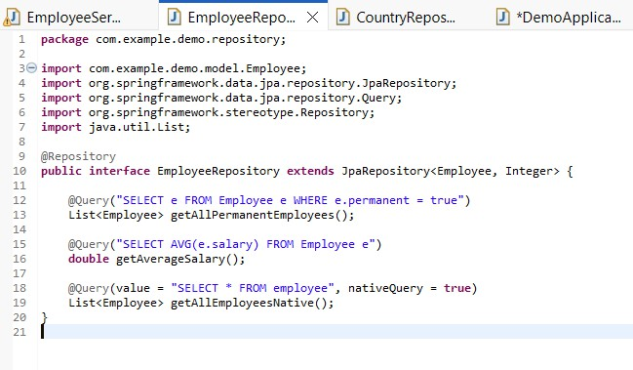**EmployeeService.java:**

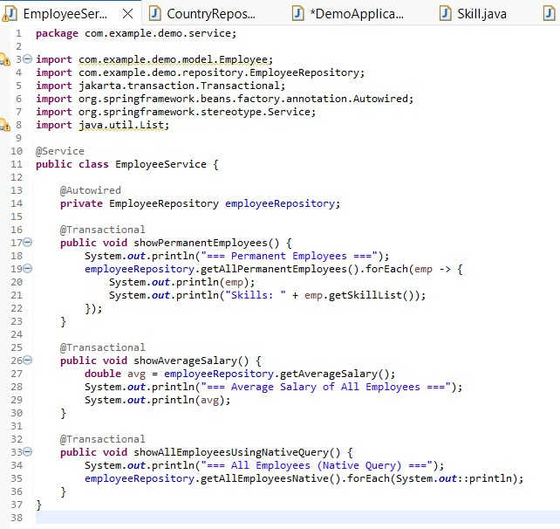

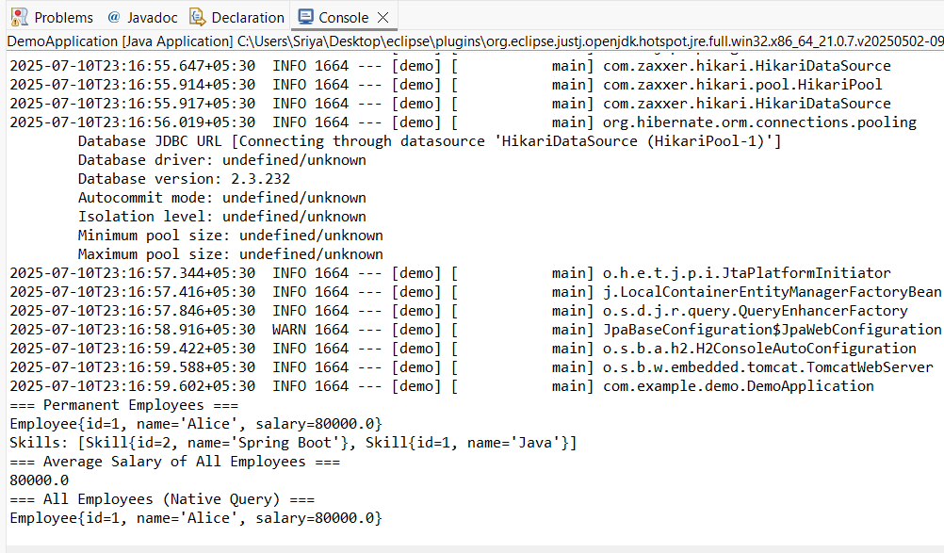

**Employee.java:**

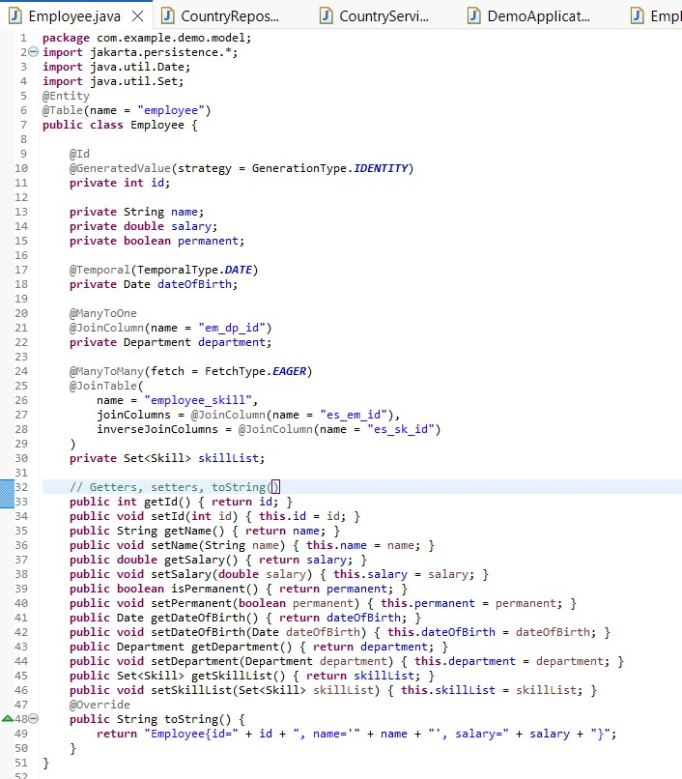

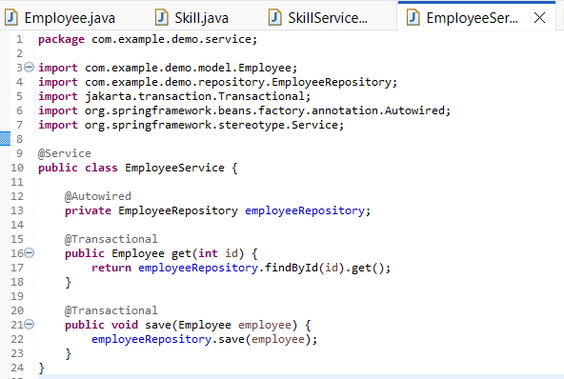

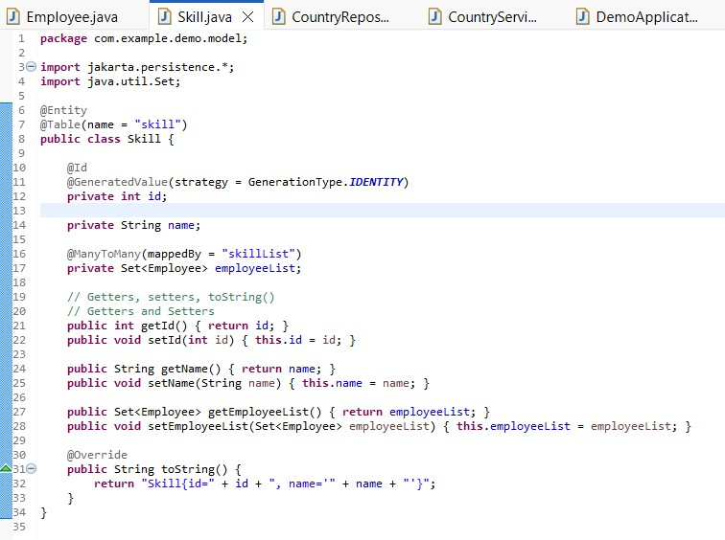**Skill.java:**

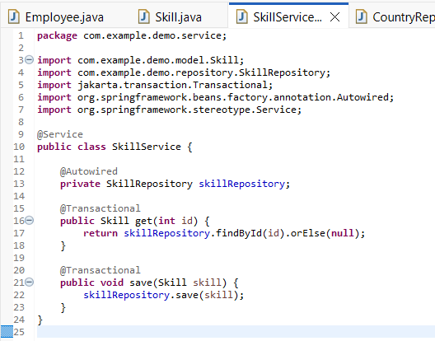

**application properties:**

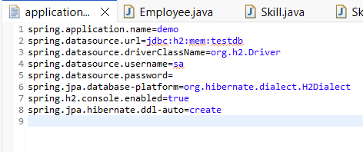

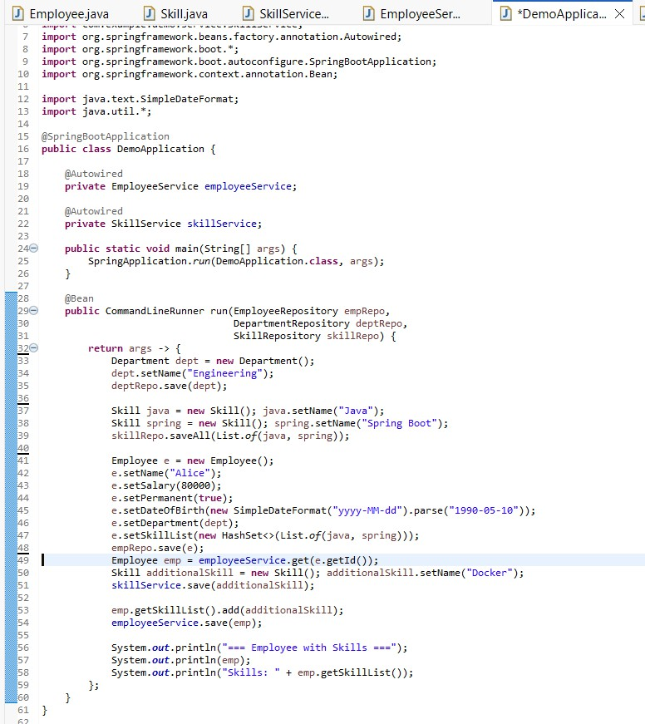

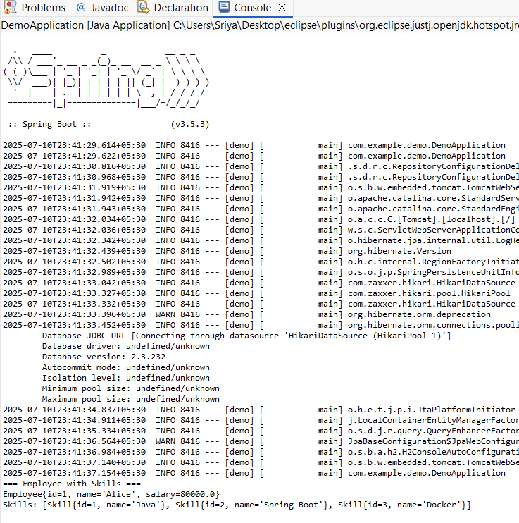**Output:**